Please find below a brief overview on MVAS for Chapel Road & Brinkley Road

It appears that the 'signs' are a good deterrent in slowing down vehicles as they enter the village but they also highlight the excessive speed that vehicles are exiting the village.

We will never stop 'speeding' but they seem to remind people to slow down.

I am open to ideas or suggestions on where to site the signs next please ? Should we turn them round so it slows vehicles down exiting the village ??

Chapel Road 03/07/25 - 07/08/25

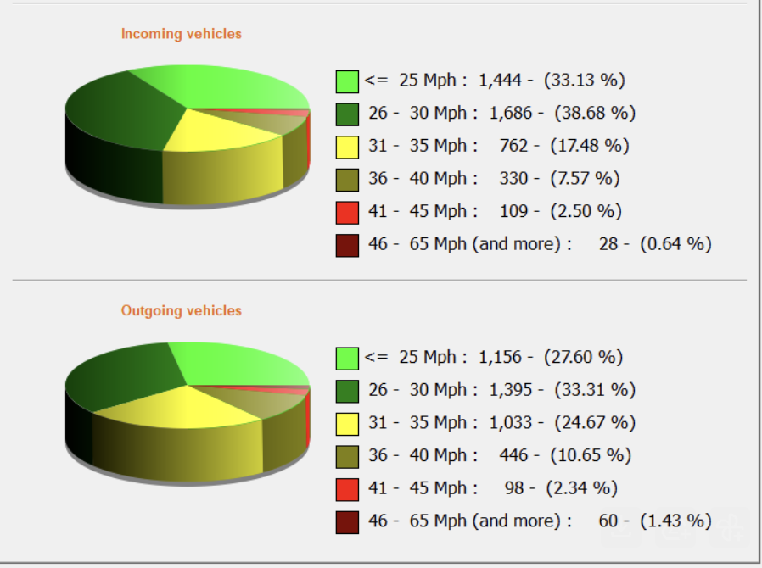
Incoming 4359 Outgoing 4188

01/08 11.25 64mph 24/07 09.08 76mph
05/07 15.06 58mph 07/08 16.52 75mph
13/07 10.45 57mph 22/07 13.57 73mph

Brinkley Road 03/07/25 - 27/07/25

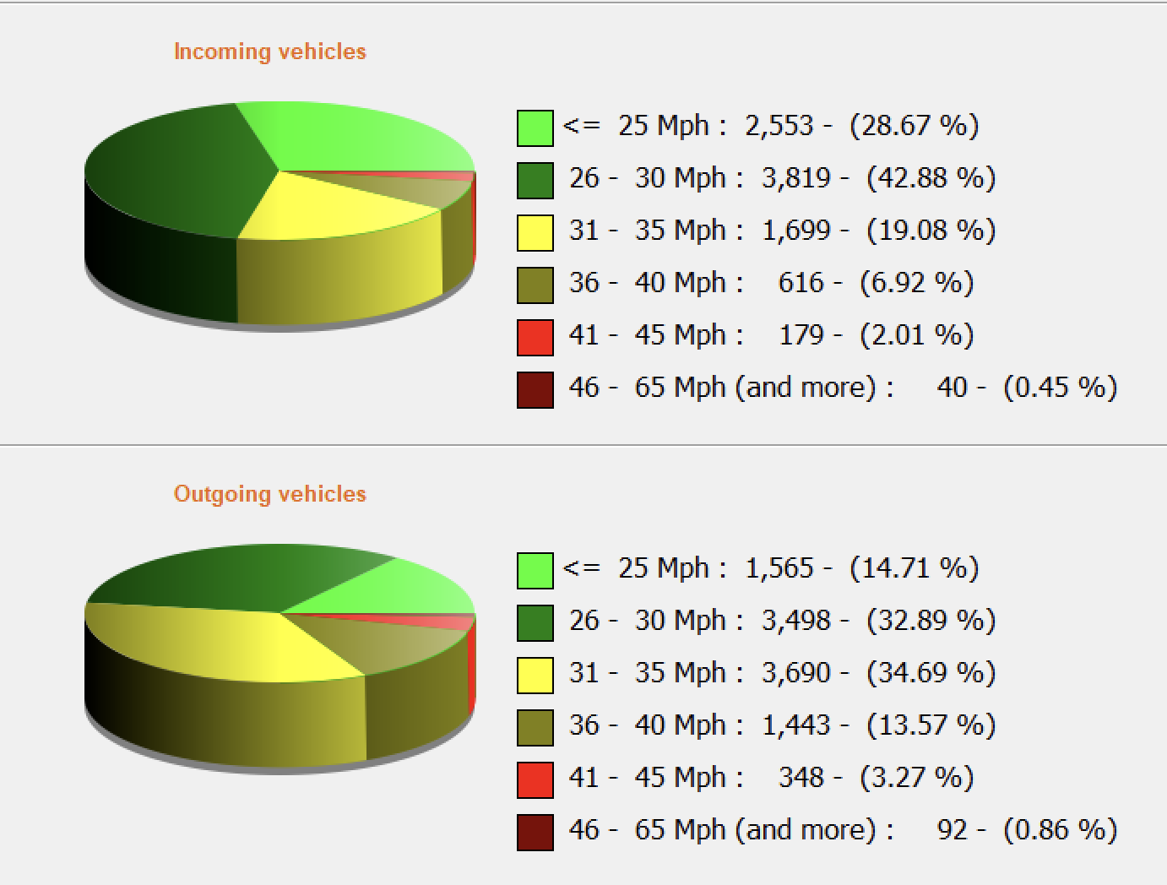
Incoming 8906 Outgoing 10636

09/07 19.12 59mph 04/07 14.54 65mph
15/07 20.24 57mph 07/07 15.58 61mph
21/07 20.38 57mph 05/07 22.13 60mph

